About Program Notes

Programs for performances can disperse valuable and interesting information. They also make terrific souvenirs for the cast.

We require that you include the following:

- The Missoula Children’s Theatre authorship credits for key creative personnel and copyright information found on the next page.

We encourage you to include the following at your discretion, should room permit:

- The included show synopsis and MCT company overview.

- All foundation and/or arts organization graphics included.

- Any local sponsoring organization logo or information.

- Complete list of cast members, assistant directors, accompanist, lighting technician, school staff and anyone else who helped to make your week a success.

Along with the following statements:

- There should be no flash photography during the performance. There will be a time for photos immediately following the show.

- Please observe the following video courtesies: keep the aisles clear and stay in one place while recording.

- Please silence all cell phones.

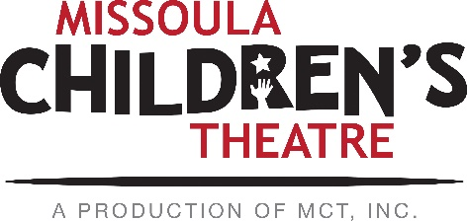  Celebrating over 50 years of touring, the Missoula Children’s Theatre International Tour has fostered developmental life skills in more than a million kids. Our tour reaches 65,000 children in more than 1,000 communities in all 50 states and 15+ countries each year. One of the many ways the Missoula Children’s Theatre remains vibrant is through generous donors all over the world. If you would like to support MCT, visit MCTinc.org/give or text “MCTGive” to 44321.  “Guess what? I made it…I’m in the play!”  On stage or behind the scenes, your child is a STAR! We invite you to honor their experience with a “star” in the MCT Galaxy, located in MCT headquarters in Missoula, MT! To see a sample of a star and learn more about this unique way to celebrate your child and support MCT, visit MCTinc.org/get-involved/mct-galaxy-wall. Stars are only $50 and can be customized with a name, the memory you wish to commemorate, date and location.  Missoula Children’s Theatre  200 N. Adams, Missoula, MT 59802-4718  MCTinc.org 406-728-1911 tour@MCTinc.org  Cast of Characters:  Jim Hawkins  Pirates  Cap’n Patches  Davey the Letterman  Singin’ Sam  Goldie  Rhode Island Red  Snowy Owl  Blue Jay  Lookout Outlook  Hawkins Sisters  Jeannie  Janie  Jennie  Joanie  Jonna  Jan  Cap’n Flint  Stranger  Mother Hawkins  Ruffians  Treasures  Mariners  Gulls  Assistant Directors  Accompanist  Long John Silver–Tour Actor/Director  Director–Tour Actor/Director |  |  |  | 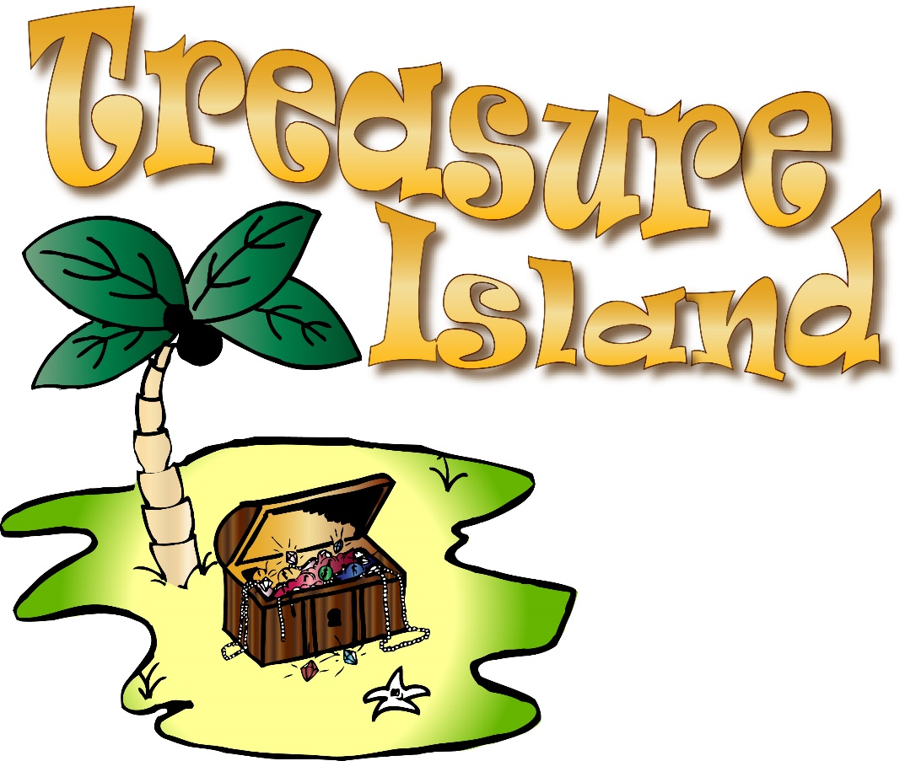  Originally developed by the Missoula Children's Theatre  in partnership with Northwestern Energy  Adapted by  JIM CARON  Music and Lyrics by  JIM CARON and MICHAEL MCGILL  Copyright © 2011 MCT, Inc.  MISSOULA CHILDREN’S THEATRE (MCT, INC)  200 North Adams Missoula, Montana 59802-4718  Phone 406-728-1911 Fax 406-721-0637  MCTinc.org  All Rights Reserved  TREASURE ISLAND SYNOPSIS  The Missoula Children's Theatre takes pride in presenting TREASURE ISLAND, an original adaptation of Robert Louis Stevenson’s epic novel. Young Jim Hawkins, a mischievous lad, lives with his mother and six sisters in a seaside village on the coast of Maine. The year is 1782 and the American War for Revolution is in its last days. Longing for adventure, Jim comes under the hypnotic spell of the legendary pirate, Long John Silver. While waiting tables in the family Inn, Jim finds a treasure map and, with the villainous Silver as his seeming mentor, sails uncharted seas with only the ragged map and a flock of Gulls as guides. Always up for adventure, Jim’s Ruffian friends say farewell to their village parents and serve as cabin boys for Silver and his band of hilarious (although unsavory) pirate types. Once on the island, nights are sleepless as true colors are revealed in our hero’s quest for the proverbial happy ending. Then - at last - the treasure is found and hand in hand we’re homeward bound.  TOUR SPONSORS

