About Program Notes

Programs for performances can disperse valuable and interesting information. They also make terrific souvenirs for the cast.

We require that you include the following:

- The Missoula Children’s Theatre authorship credits for key creative personnel and copyright information found on the next page.

We encourage you to include the following at your discretion, should room permit:

- The included show synopsis and MCT company overview.

- All foundation and/or arts organization graphics included.

- Any local sponsoring organization logo or information.

- Complete list of cast members, assistant directors, accompanist, lighting technician, school staff and anyone else who helped to make your week a success.

Along with the following statements:

- There should be no flash photography during the performance. There will be a time for photos immediately following the show.

- Please observe the following video courtesies: keep the aisles clear and stay in one place while recording.

- Please silence all cell phones.

  Celebrating our 50th year of touring, the Missoula Children’s Theatre International Tour has fostered developmental life skills in more than a million kids. Prior to Covid, we worked with 65,000 children in more than 1,100 communities in all 50 states and 17 countries each year. Our reach is increasing once again, but like all performing arts organizations, Covid-19 has had a devastating impact on our budget. One of the many ways the Missoula Children’s Theatre remains vibrant is through generous donors all over the world. If you would like to help support MCT, GIVE online by visiting MCTinc.org or via text by texting “MCTGive” to 44321.    “Guess what? I made it…I’m in the play!”  On stage or behind the scenes, your children are STARS! We invite you to honor that experience with a “star” in the MCT Galaxy, located in MCT headquarters in Missoula, MT! To see a sample of the MCT Galaxy and learn more about this exciting way to celebrate your star and support MCT, search “galaxy” in the search bar on our website. Stars are only $50 and can be customized with a name, the memory you wish to commemorate, date and location.    Missoula Children’s Theatre  200 N. Adams, Missoula, MT 59802-4718  MCTinc.org 406-728-1911 tour@MCTinc.org |  | 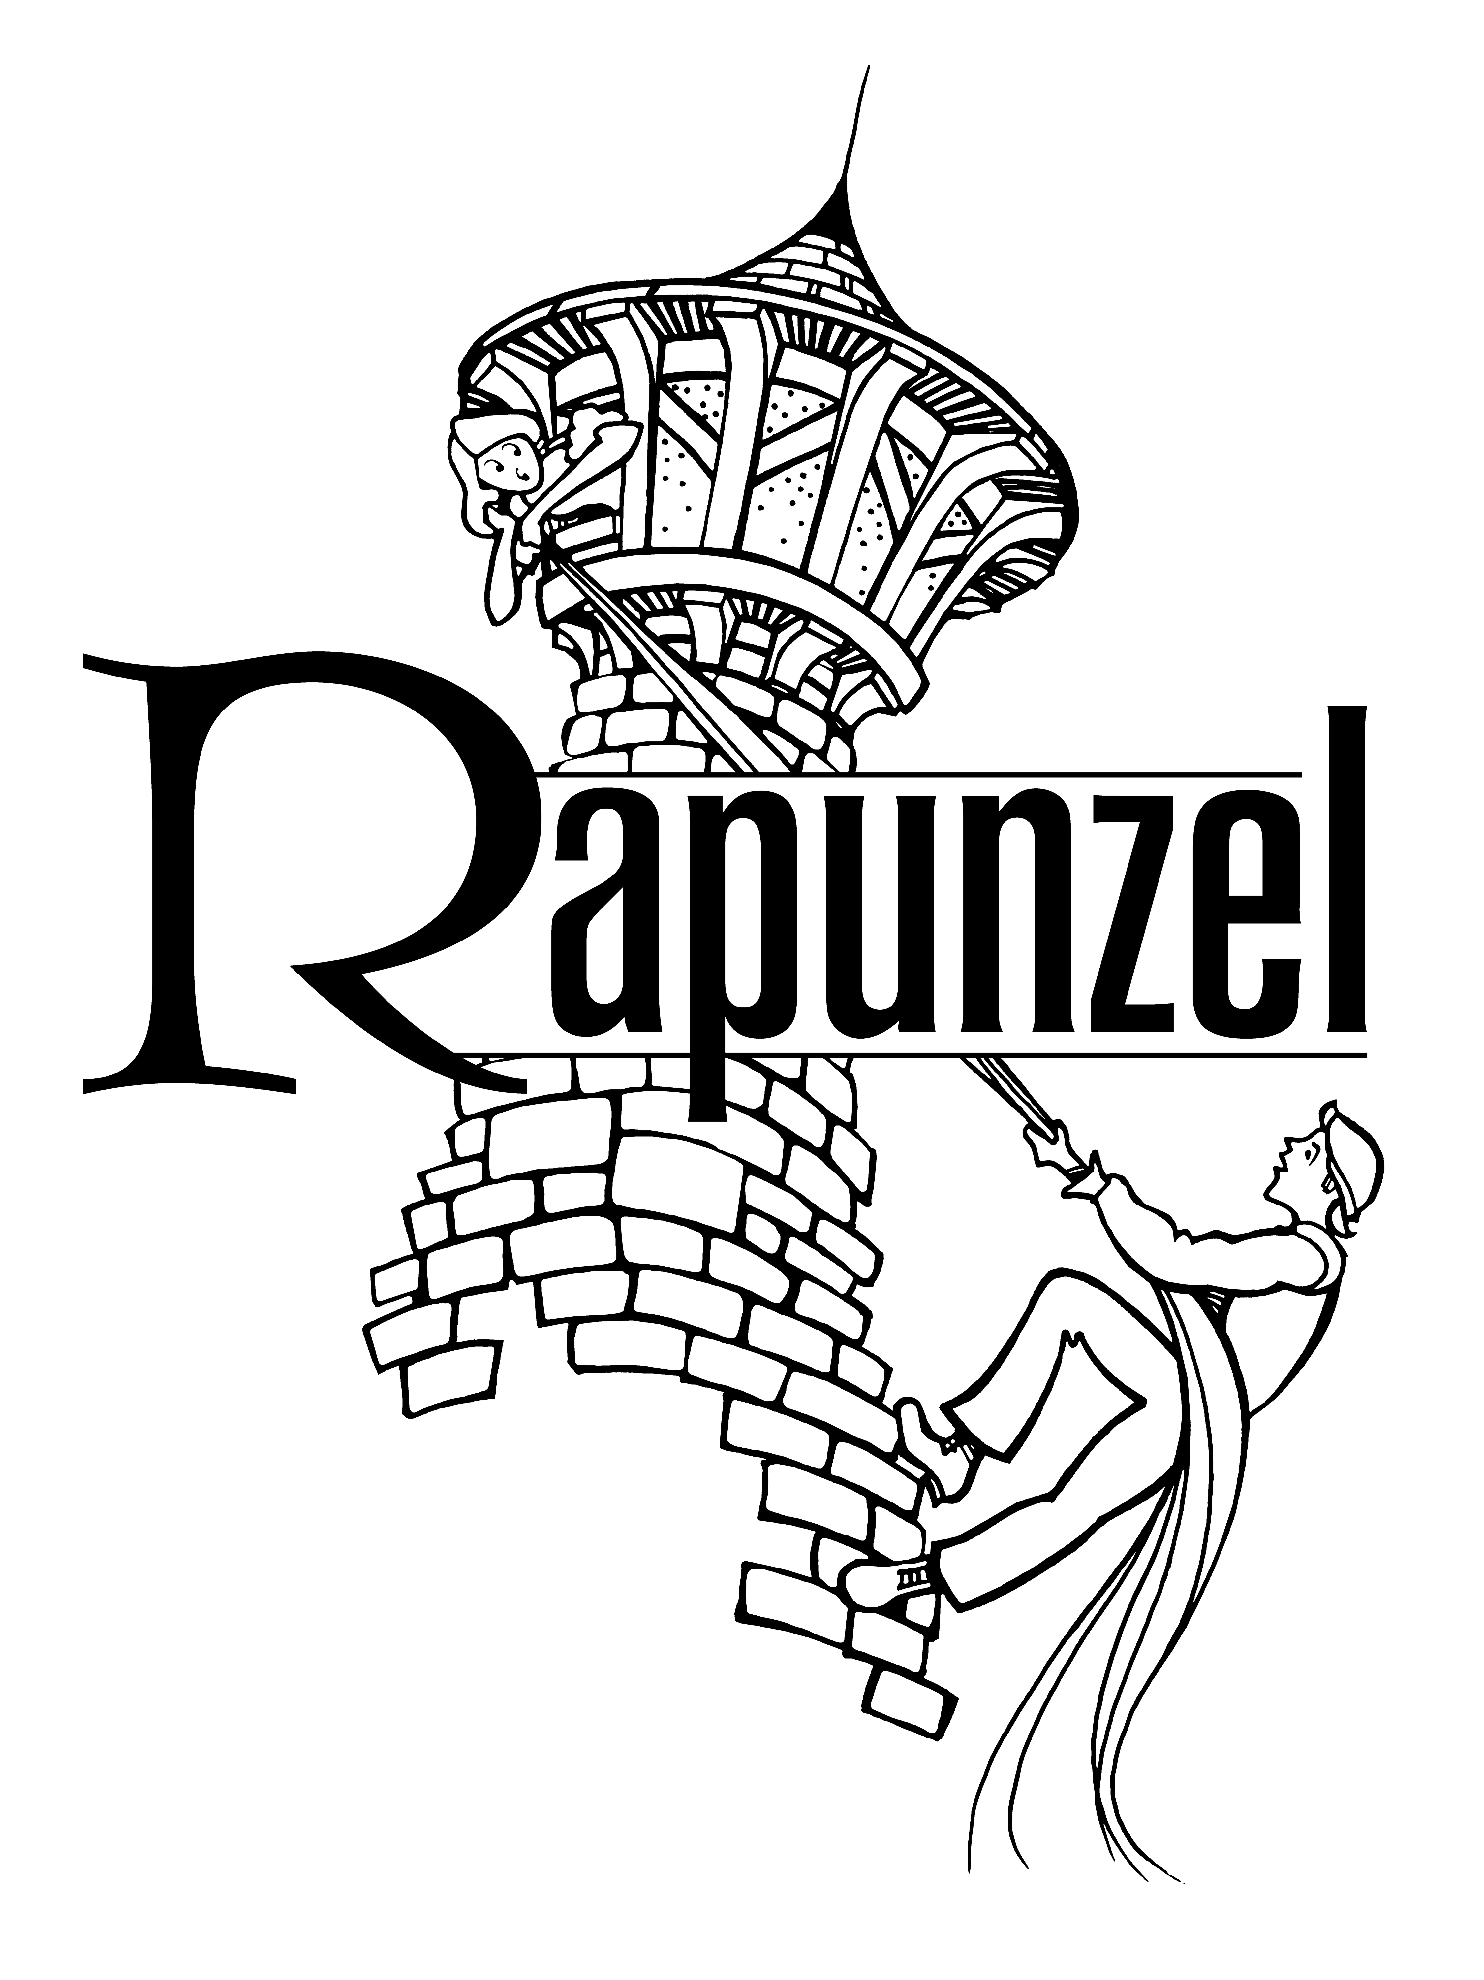  Adapted by  MICHAEL MCGILL  Music and Lyrics by  Michael McGill  Copyright © 2012 MCT, Inc.  MISSOULA CHILDREN’S THEATRE (MCT, INC)  200 North Adams Missoula, Montana 59802-4718  Phone 406-728-1911 Fax 406-721-0637  MCTinc.org  All Rights Reserved

Cast of Characters:  Tower Rapunzel  Room Rapunzel  Prince #1  Prince #2  Madame Gothel  Maurice  Monique  Wood Elves  Ears of Corn  Potato  Unicorns  Pixies  Gremlins  Billy Goats Gruff  Troll  Three Bears  Bucky the Beaver  Ogres  Fun Gus  Mushrooms  Assistant Directors  Accompanist  Frenchy–Tour Actor/Director  Director–Tour Actor/Director |  | .  RAPUNZEL SYNOPSIS  Would it surprise you to know that the story of Rapunzel happened in France? Well it didn’t really, but our story takes you on a frivolous frolic through the French countryside. The Ogres garden in the Mushroom patch while the Corn and Potato spies report back to Madame Gothel. Frenchy and his intense friends, the Wood Elves, do their best to help Rapunzel escape the grasp of Madame Gothel. The lost Prince, Rapunzel’s parents, and her friends the Unicorns try to help. Just when you think it’s safe to cross the bridge, a Troll and Three Billy Goats Gruff get in the way. It doesn’t help that the Three Bears (or is it four) confuse Rapunzel with Goldilocks and chase her through the forest. Add to that the Gremlins trying to play tricks on everyone, and you have chaos! Well, it’s not that bad because the Pixies foil the Gremlins’ plans most of the time. In short, Rapunzel and all the rest of the characters tell a silly tale of personal triumph and friendship.  TOUR SPONSORS  The Missoula Children’s Theatre domestic Tour is sponsored by Cosmic Crisp®, a new apple grown exclusively in Washington state. The Cosmic Crisp® motto, “Imagine the Possibilities™”, aligns with MCT’s work sparking children’s imaginations and creativity through theatre participation.    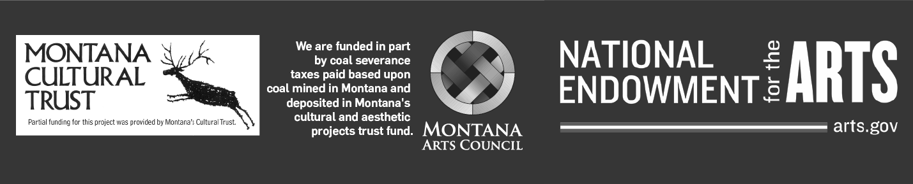  This project is partially supported by the National Endowment for the Arts. Supported in part by a grant from the Montana Arts Council, an agency of the State Government, and the National Endowment for the Arts.

