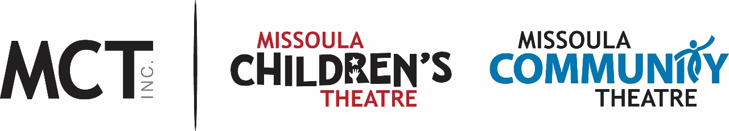

FOR IMMEDIATE RELEASE
Missoula Community Theatre postpones Matilda the Musical
MISSOULA, MT: In light of the rapidly-changing situation around the Coronavirus/COVID-19 outbreak and recommendations from health professionals as well as local, state and federal officials regarding “social distancing,” the Missoula Community Theatre has made the difficult decision to postpone Matilda the Musical, the final production of the 2019-2020 season, which was April 23-May 10th. MCT is working to reschedule the show for this fall, and the date is TBA as of this press announcement.
MCT will have more information and solidified dates in the coming weeks as they negotiate terms with the royalty house that owns the rights to the show. In the interim, MCT will hold current reservations with the intention of rescheduling patrons to a comparable date in the fall.
Patrons may choose to wait until dates are confirmed and they will hear from patron services to re-schedule their tickets or they may also request a refund. If they are able and willing to donate back to MCT the price of their ticket in lieu of a refund, they will receive a tax-deductible receipt. The Box Office number is 406-728-PLAY (7529) and note there are new hours for the foreseeable future of 10am-3pm, M-F.
MCT is grateful for the patrons, volunteers, sponsors, advertisers and all supporters for their trust. These are unprecedented times of challenge for every family and business. Here’s to better days as the community comes together (while apart) to weather the crisis. Please visit www.MCTinc.org for further updates and announcements regarding events and productions.

For media interviews, contact Terri Elander, Public Relations Director at telander@MCTinc.org or 406-829-5218.

