ABOUT PROGRAM NOTES

Programs for performances can disperse valuable and interesting information. They also make terrific souvenirs for the cast.

We require that you include the following:

- The Missoula Children’s Theatre authorship credits for key creative personnel and copyright information found on the next page.

We encourage you to include the following at your discretion, should room permit:

- The included show synopsis and MCT company overview on back page.

- All foundation and/or arts organization graphics included.

- Any local sponsoring organization logo or information.

- Complete list of cast members, assistant directors, accompanist, lighting technician, school staff and anyone else who helped to make your week a success.

Along with the following statements:

- There should be no flash photography during the performance. There will be a time for photos immediately following the show.

- Please observe the following video courtesies: keep the aisles clear and stay in one place while recording.

- Please silence all cell phones.

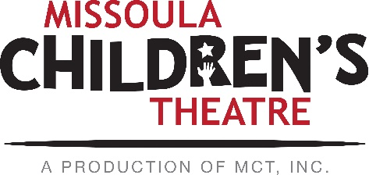  Throughout its 45 year existence, the Missoula Children’s Theatre International Tour has fostered developmental life skills in more than a million kids. Just this year, we will work with 65,000 children in more than 1,200 communities in all 50 states and 17 countries. The Missoula Children’s Theatre relies on your generosity to close the gap between low tour fees and the actual cost of touring. If our program has had a positive impact on you or a family member, and you would like to help ensure this experience for future generations, please contact bfrazee@MCTinc.org.  Federal employees can contribute through the Combined Federal Campaign using CFC code #20396.  “Guess what? I made it…I’m in the play!”  On stage or behind the scenes, your children are stars! Maybe this is their first show, or they've been in 12 MCT shows. Either way, their Missoula Children’s Theatre experience will always shine bright. We invite you to honor that experience with a “star” in the MCT Galaxy, located in MCT headquarters in Missoula! How many stars are in the galaxy? When you participate, the sky's the limit! You may even want one of your own for being your child’s life-long stage manager. To see a sample of the MCT Galaxy and learn more about this exciting, new way to celebrate your star, visit MCTtinc.org/mct-galaxy.  Missoula Children’s Theatre  200 N. Adams, Missoula, MT 59802-4718  MCTinc.org 406-728-1911 tour@MCTinc.org |  |  |  | 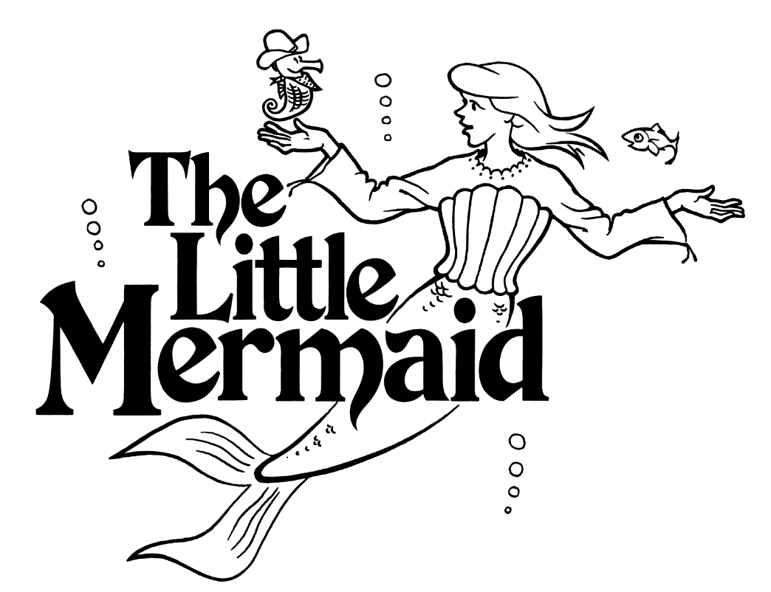  Adapted by  JIM CARON  Music and Lyrics by  Michael McGill AND JIM CARON  Copyright © 2005, 2006 Jim Caron, Michael McGill & MCT, Inc.  MISSOULA CHILDREN’S THEATRE (MCT, INC)  200 North Adams Missoula, Montana 59802-4718  Phone 406-728-1911 Fax 406-721-0637  www.MCTinc.org  All Rights Reserved
Cast of Characters:  Celia  Delia  Amelia  Ophelia  Gil  Prince  King  Queen  Starfish  Sea Scouts  Seasiders  Town Criers  Seahorses  Assistant Directors  Accompanist  Professor Thumperdumper/Mrs. Merman-Tour Actor/Director  Director-Tour Actor/Director |  |  |  | THE LITTLE MERMAID SYNOPSIS  Deep in the salty waters of the Sassafras Sea, there lived a Little Mermaid. Her name was Celia. She lived for music. In fact, it was said that she had the loveliest scales in all of the Deep. Celia and her three sisters were allowed one visit to the World Above, each on their sixteenth birthday, to learn the secrets of life on dry land. Their discoveries included ferocious dragons, advancing armies and, of course, a handsome and resourceful Prince Charming. In a new version of the age-old tale, lots of music, plot surprises and humor await the audience.  TOUR SPONSORS  The Missoula Children’s Theatre domestic Tour is sponsored by Cosmic Crisp®, a new apple grown exclusively in Washington state. The Cosmic Crisp® motto, “Imagine the Possibilities™”, aligns with MCT’s work sparking children’s imaginations and creativity through theatre participation.  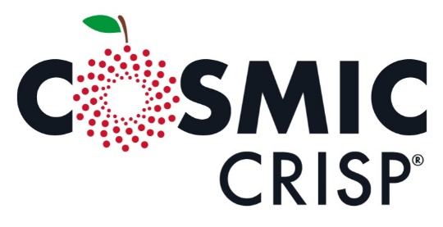  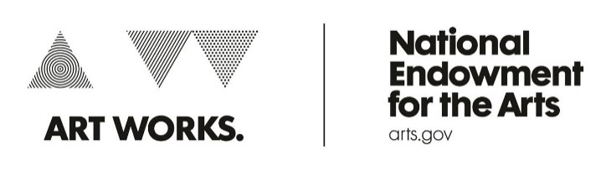  This project is partially supported by the National Endowment for the Arts. Supported in part by a grant from the Montana Arts Council, an agency of the State Government, and the National Endowment for the Arts.

