About Program Notes

Programs for performances can disperse valuable and interesting information. They also make terrific souvenirs for the cast.

We require that you include the following:

- The Missoula Children’s Theatre authorship credits for key creative personnel and copyright information found on the next page.

We encourage you to include the following at your discretion, should room permit:

- The included show synopsis and MCT company overview.

- All foundation and/or arts organization graphics included.

- Any local sponsoring organization logo or information.

- Complete list of cast members, assistant directors, accompanist, lighting technician, school staff and anyone else who helped to make your week a success.

Along with the following statements:

- There should be no flash photography during the performance. There will be a time for photos immediately following the show.

- Please observe the following video courtesies: keep the aisles clear and stay in one place while recording.

- Please silence all cell phones.

2020-2021 SCHOOL YEAR

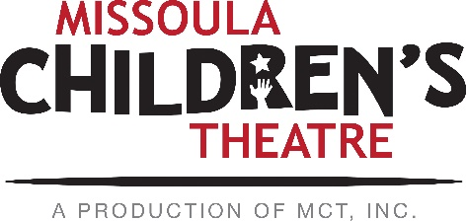  Throughout its 45 year existence, the Missoula Children’s Theatre International Tour has fostered developmental life skills in more than a million kids. Just this year, we will work with 65,000 children in more than 1,200 communities in all 50 states and 17 countries. The Missoula Children’s Theatre relies on your generosity to close the gap between low tour fees and the actual cost of touring. If our program has had a positive impact on you or a family member, and you would like to help ensure this experience for future generations, please contact bfrazee@MCTinc.org.  Federal employees can contribute through the Combined Federal Campaign using CFC code #20396.  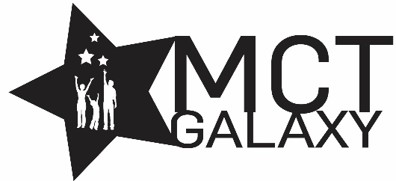  “Guess what? I made it…I’m in the play!”  On stage or behind the scenes, your children are stars! Maybe this is their first show, or they've been in 12 MCT shows. Either way, their Missoula Children’s Theatre experience will always shine bright. We invite you to honor that experience with a “star” in the MCT Galaxy, located in MCT headquarters in Missoula! How many stars are in the galaxy? When you participate, the sky's the limit! You may even want one of your own for being your child’s life-long stage manager. To see a sample of the MCT Galaxy and learn more about this exciting, new way to celebrate your star, visit MCTinc.org/mct-galaxy.  Missoula Children’s Theatre  200 N. Adams, Missoula, MT 59802-4718  MCTinc.org 406-728-1911 tour@MCTinc.org |  | 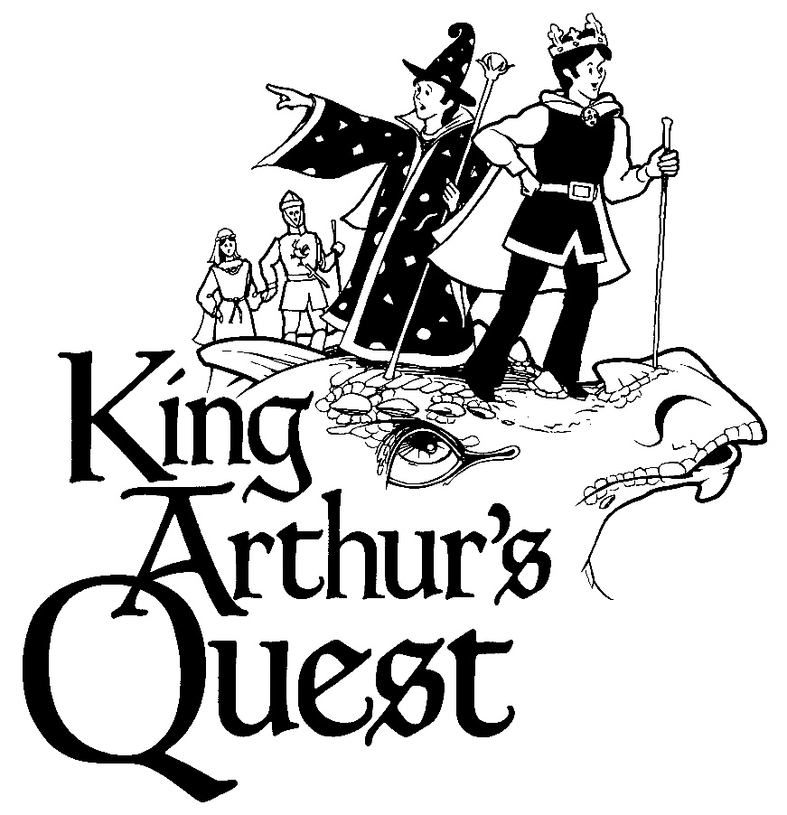  Conceived and Written by  MICHAEL MCGILL  Music and Lyrics by  Michael McGill  Additional Music and Lyrics  REBECCA MCGILL  Copyright © 2011 MCT, Inc.  MISSOULA CHILDREN’S THEATRE (MCT, INC)  200 North Adams Missoula, Montana 59802-4718  Phone 406-728-1911 Fax 406-721-0637  MCTinc.org  All Rights Reserved
Cast of Characters:  King Arthur  Guinevere  Sir Lancelot  Merlin  The Raven  Taleisin  Uther Pendragon  Mordred  Morgan Le Fey  Lady of the Lake  The Knights of the Round Table  Sir Galahad, the White Knight  Sir Dinadin, the Black Knight  Sir Kay, the Blue Knight  Sir Yvain, the Red Knight  Sir Gawain, the Green Knight  Sir Erec, the Yellow Knight  Damsels of the First Order  Damsel of the Second Order  The Squires  White Squire  Black Squire  Blue Squire  Red Squire  Green Squire  Yellow Squire  Camelotians – The Citizens of Camelot  The Minis  Assistant Directors  Accompanist  Keeper of the Keep, Recalcitrant Giant, Intractable Dragon–  Tour Actor/Director  Director-Tour Actor/Director |  | KING ARTHUR’S QUEST SYNOPSIS  King Arthur, of legend and song, strode across Medieval England with courage and confidence…or did he? What if the troubles of his kingdom threatened to overwhelm him? Watch the Damsels in Distress sound the warning of trouble. Witness the Lady of the Lake as she produces the sword in the stone. Hide with the Camelotians when the Ghost of Arthur’s father visits the castle. See the Giant tower over the questing knights. Cheer for the King when he makes friends with the terrible dragon. Listen in as Morgan le Fey and Mordred propose a better plan. Join the Knights and Squires of the Round Table as they try to do the right thing. Hope for the best outcome as your favorite characters of Camelot - Arthur, Guinevere, Merlin, Taleisin, The Raven, and Lancelot wrestle with the challenges faced by their people. Follow the original twist on this familiar story as it weaves its way through a landscape full of surprises!  TOUR SPONSORS  The Missoula Children’s Theatre domestic Tour is sponsored by Cosmic Crisp®, a new apple grown exclusively in Washington state. The Cosmic Crisp® motto, “Imagine the Possibilities™”, aligns with MCT’s work sparking children’s imaginations and creativity through theatre participation.  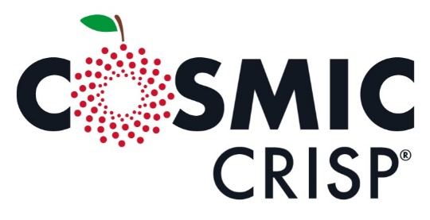  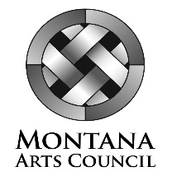  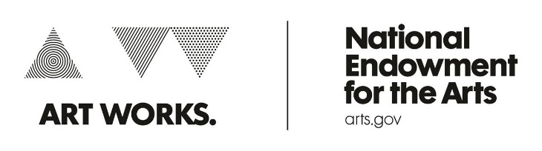  This project is partially supported by the National Endowment for the Arts. Supported in part by a grant from the Montana Arts Council, an agency of the State Government, and the National Endowment for the Arts.

