ABOUT PROGRAM NOTES

Programs for performances can disperse valuable and interesting information. They also make terrific souvenirs for the cast.

We require that you include the following:

- The Missoula Children’s Theatre authorship credits for key creative personnel and copyright information found on the next page.

We encourage you to include the following at your discretion, should room permit:

- The included show synopsis and MCT company overview.

- All foundation and/or arts organization graphics included.

- Any local sponsoring organization logo or information.

- Complete list of cast members, assistant directors, accompanist, lighting technician, school staff and anyone else who helped to make your week a success.

Along with the following statements:

- There should be no flash photography during the performance. There will be a time for photos immediately following the show.

- Please observe the following video courtesies: keep the aisles clear and stay in one place while recording.

- Please silence all cell phones.

2020-2021 SCHOOL YEAR

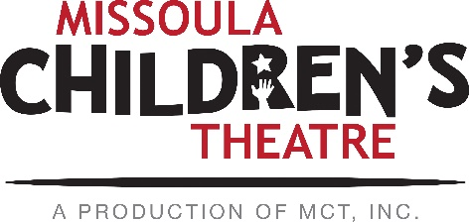  Throughout its 45 year existence, the Missoula Children’s Theatre International Tour has fostered developmental life skills in more than a million kids. Just this year, we will work with 65,000 children in more than 1,200 communities in all 50 states and 17 countries. The Missoula Children’s Theatre relies on your generosity to close the gap between low tour fees and the actual cost of touring. If our program has had a positive impact on you or a family member, and you would like to help ensure this experience for future generations, please contact Bfrazee@MCTinc.org.  Federal employees can contribute through the Combined Federal Campaign using CFC code #20396.  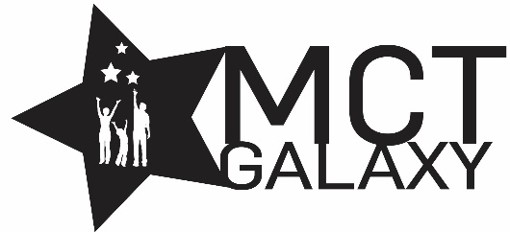  “Guess what? I made it…I’m in the play!”  On stage or behind the scenes, your children are stars! Maybe this is their first show, or they've been in 12 MCT shows. Either way, their Missoula Children’s Theatre experience will always shine bright. We invite you to honor that experience with a “star” in the MCT Galaxy, located in MCT headquarters in Missoula! How many stars are in the galaxy? When you participate, the sky's the limit! You may even want one of your own for being your child’s life-long stage manager. To see a sample of the MCT Galaxy and learn more about this exciting, new way to celebrate your star, visit MCTtinc.org/mct-galaxy.  Missoula Children’s Theatre  200 N. Adams, Missoula, MT 59802-4718  MCTinc.org 406-728-1911 tour@MCTinc.org |  |  |  | 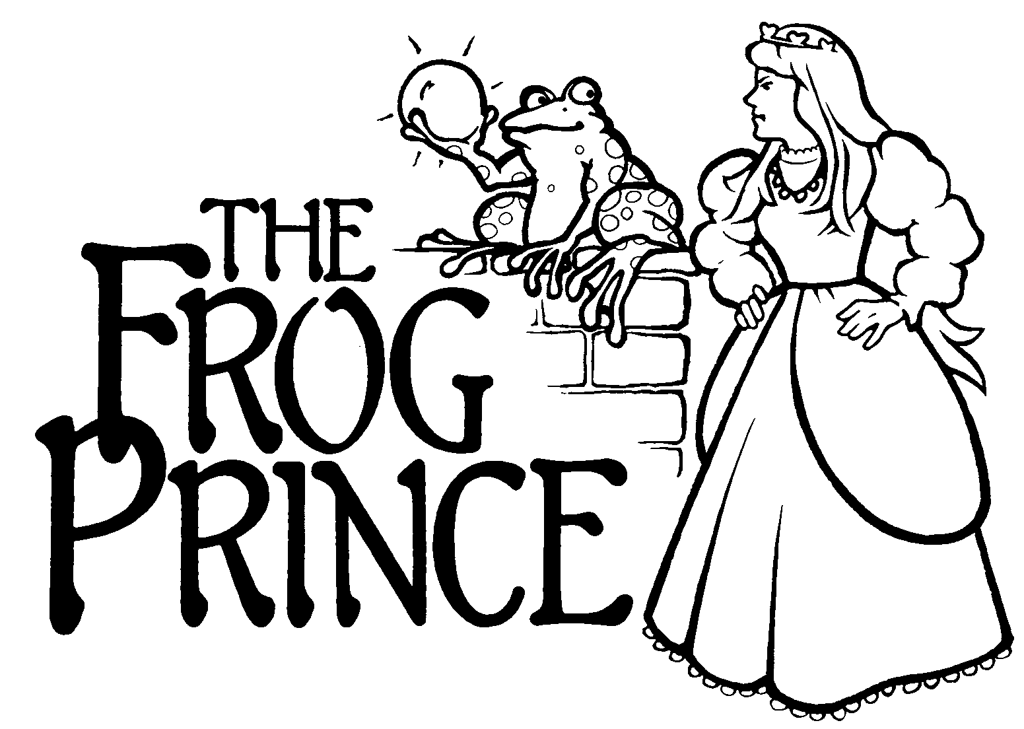  Conceived and Written by Music and Lyrics by  MICHAEL MCGILL MICHAEL MCGILL  Additional Music by  REBECCA MCGILL  Copyright © 2002, 2011 MCT, Inc.  MISSOULA CHILDREN’S THEATRE (MCT, INC)  200 North Adams Missoula, Montana 59802-4718  Phone 406-728-1911 Fax 406-721-0637  MCTinc.org  All Rights Reserved
Cast of Characters:  Swamp Frog  Castle Frog/Prince  Ollie Aspen Tree  Princess Prim  Princess Proper  Princess Peppy  Knights  Swamp Things  Bert the Alligator  Flamingos  Ducks  The Fly  Venus Fly Traps  Assistant Directors  Accompanist  Jones / Maria (or Captain) Von Fly Trap / Queen (or King)  – Tour Actor/Director  Director—Tour Actor/Director |  |  | THE FROG PRINCE SYNOPSIS  Deep in the royal swamp, a lonely Frog retrieves a golden ball for Princess Prim in exchange for friendship and comfort. The selfish princess doesn’t want to live up to her part of the bargain and puts her royal Knights on alert. And so the trouble begins. Luckily, Frog gets some good advice from Ollie the wise old Aspen tree, the well-read Alligator, and the kindly Swamp Things. The Ducks, a busy Fly, and dancing Flamingos also come to Frog’s assistance as the Frog’s kindly servant tirelessly tries to set things right. Even the kindly Princess Proper and spunky Princess Peppy get involved and, despite the trouble caused by the mischievous Venus Fly Traps, all ends happily. Our hero becomes a Prince (formerly known as Frog) and realizes that friendships are made, not bought—and he discovers that it is not what you are but who you are that counts.  TOUR SPONSORS  The Missoula Children’s Theatre domestic Tour is sponsored by Cosmic Crisp®, a new apple grown exclusively in Washington state. The Cosmic Crisp® motto, “Imagine the Possibilities™”, aligns with MCT’s work sparking children’s imaginations and creativity through theatre participation.  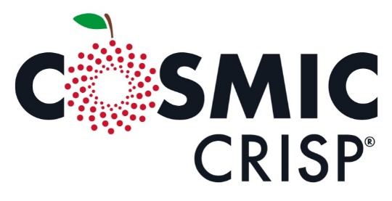  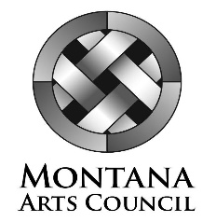  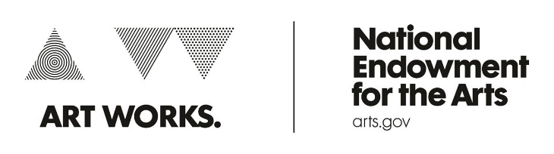  This project is partially supported by the National Endowment for the Arts. Supported in part by a grant from the Montana Arts Council, an agency of the State Government, and the National Endowment for the Arts.

