ABOUT PROGRAM NOTES

Programs for performances can disperse valuable and interesting information. They also make terrific souvenirs for the cast.

We require that you include the following:

- The Missoula Children’s Theatre authorship credits for key creative personnel and copyright information found on the next page.

We encourage you to include the following at your discretion, should room permit:

- The included show synopsis and MCT company overview.

- All foundation and/or arts organization graphics included.

- Any local sponsoring organization logo or information.

- Complete list of cast members, assistant directors, accompanist, lighting technician, school staff and anyone else who helped to make your week a success.

Along with the following statements:

- There should be no flash photography during the performance. There will be a time for photos immediately following the show.

- Please observe the following video courtesies: keep the aisles clear and stay in one place while recording.

- Please silence all cell phones.

2020-2021 SCHOOL YEAR
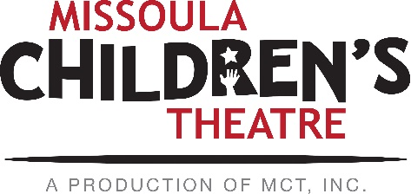  Throughout its 45 year existence, the Missoula Children’s Theatre International Tour has fostered developmental life skills in more than a million kids. Just this year, we will work with 65,000 children in more than 1,200 communities in all 50 states and 17 countries. The Missoula Children’s Theatre relies on your generosity to close the gap between low tour fees and the actual cost of touring. If our program has had a positive impact on you or a family member, and you would like to help ensure this experience for future generations, please contact bfrazee@MCTinc.org.  Federal employees can contribute through the Combined Federal Campaign using CFC code #20396.  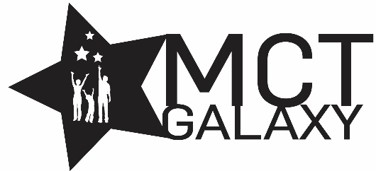  “Guess what? I made it…I’m in the play!”  On stage or behind the scenes, your children are stars! Maybe this is their first show, or they've been in 12 MCT shows. Either way, their Missoula Children’s Theatre experience will always shine bright. We invite you to honor that experience with a “star” in the MCT Galaxy, located in MCT headquarters in Missoula! How many stars are in the galaxy? When you participate, the sky's the limit! You may even want one of your own for being your child’s life-long stage manager. To see a sample of the MCT Galaxy and learn more about this exciting, new way to celebrate your star, visit MCTtinc.org/mct-galaxy.  Missoula Children’s Theatre  200 N. Adams, Missoula, MT 59802-4718  MCTinc.org 406-728-1911 tour@MCTinc.org |  | 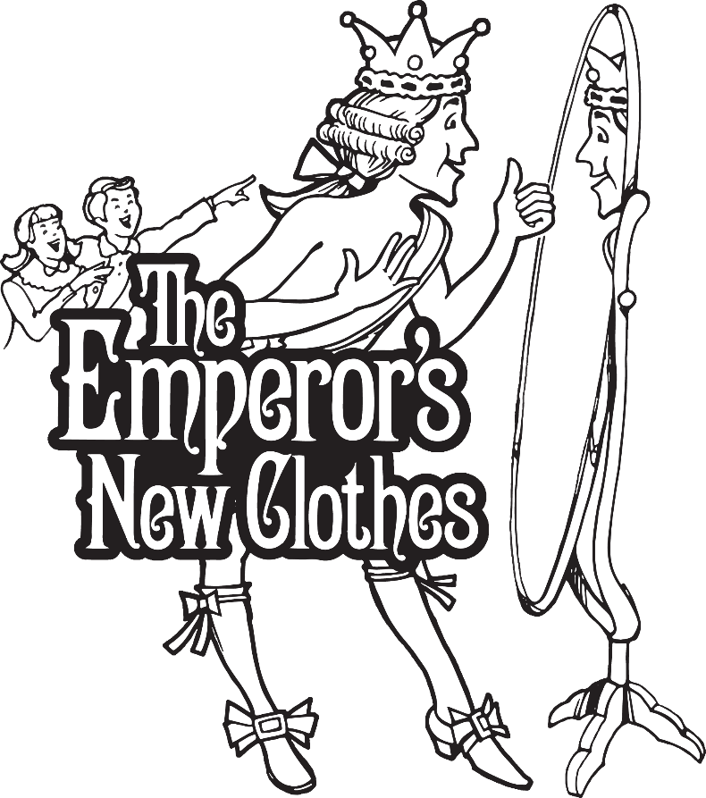  WRITTEN AND CONCEIVED BY  JIM CARON and MATT LOEHRKE  MUSIC AND LYRICS BY  JIM CARON  MICHAEL MCGILL  GREG BORIS  AMY ELLIS  Copyright © 2016 MCT, Inc.  MISSOULA CHILDREN’S THEATRE (MCT, INC)  200 North Adams Missoula, Montana 59802-4718  Phone 406-728-1911 Fax 406-721-0637  MCTinc.org  All Rights Reserved
Cast of Characters:  Emperor  ManyPenny  Royal Scholar Roxy  Royal Scholar Red  King Air  Queen Air  King Earth  Queen Earth  King Fire  Queen Fire  King Water  Queen Water  Money Council  Gem  Royal Jewelers  Boots  Royal Cobblers  Lid  Royal Hatters  Stitch  Royal Tailors  Royal Silkworms  Assistant Directors  Accompanist  Royal Scholar Rudy –Tour Actor/Director  Director–Tour Actor/Director |  | THE EMPEROR’S NEW CLOTHES SYNOPSIS  “Dress for success” is good advice that the Emperor takes whole-heartedly, wanting to impress new friends. But where to stop? When the clothes (and other people’s opinions) become more important than the people of the kingdom, trouble brews. To help their beloved Emperor find the way back to his heart, his true friends create an elaborate “birthday suit” for the Emperor to wear for his birthday parade celebration. The Emperor quickly and humbly learns that sometimes “less is more”!  TOUR SPONSORS  The Missoula Children’s Theatre domestic Tour is sponsored by Cosmic Crisp®, a new apple grown exclusively in Washington state. The Cosmic Crisp® motto, “Imagine the Possibilities™”, aligns with MCT’s work sparking children’s imaginations and creativity through theatre participation.  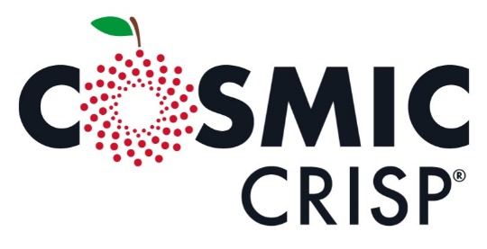  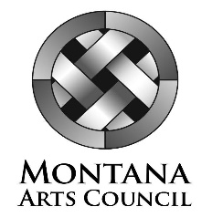  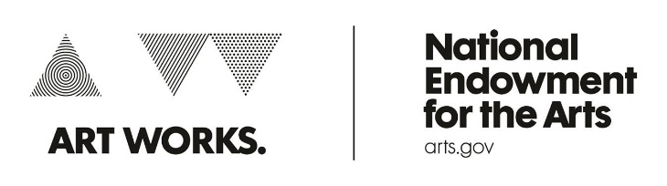  This project is partially supported by the National Endowment for the Arts. Supported in part by a grant from the Montana Arts Council, an agency of the State Government, and the National Endowment for the Arts.

