ABOUT PROGRAM NOTES

Programs for performances can disperse valuable and interesting information. They also make terrific souvenirs for the cast.

We require that you include the following:

- The Missoula Children’s Theatre authorship credits for key creative personnel and copyright information found on the next page.

We encourage you to include the following at your discretion, should room permit:

- The included show synopsis and MCT company overview.

- All foundation and/or arts organization graphics included.

- Any local sponsoring organization logo or information.

- Complete list of cast members, assistant directors, accompanist, lighting technician, school staff and anyone else who helped to make your week a success.

Along with the following statements:

- There should be no flash photography during the performance. There will be a time for photos immediately following the show.

- Please observe the following video courtesies: keep the aisles clear and stay in one place while recording.

- Please silence all cell phones.

2020-2021 SCHOOL YEAR TOUR
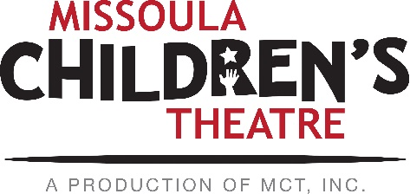  Throughout its 45 year existence, the Missoula Children’s Theatre International Tour has fostered developmental life skills in more than a million kids. Just this year, we will work with 65,000 children in more than 1,200 communities in all 50 states and 17 countries. The Missoula Children’s Theatre relies on your generosity to close the gap between low tour fees and the actual cost of touring. If our program has had a positive impact on you or a family member, and you would like to help ensure this experience for future generations, please contact bfrazee@MCTinc.org.  Federal employees can contribute through the Combined Federal Campaign using CFC code #20396.  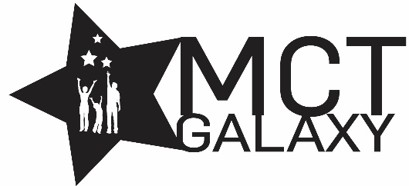  “Guess what? I made it…I’m in the play!”  On stage or behind the scenes, your children are stars! Maybe this is their first show, or they've been in 12 MCT shows. Either way, their Missoula Children’s Theatre experience will always shine bright. We invite you to honor that experience with a “star” in the MCT Galaxy, located in MCT headquarters in Missoula! How many stars are in the galaxy? When you participate, the sky's the limit! You may even want one of your own for being your child’s life-long stage manager. To see a sample of the MCT Galaxy and learn more about this exciting, new way to celebrate your star, visit MCTtinc.org/mct-galaxy.  Missoula Children’s Theatre  200 N. Adams, Missoula, MT 59802-4718  MCTinc.org 406-728-1911 tour@MCTinc.org  Cast of Characters:  Younger Beauty Lou  Older Beauty Lou  Slim  Dusty  Fleabite Clyde  Imaginary Friend  Beast  Younger Daughters  Older Daughters  Country Folk  Barnyard Critters  Assistant Directors  Accompanist  Buckaroo Bob/Bonnie–Tour Actor/Director  Director – MCT Tour Actor Director |  |  |  | 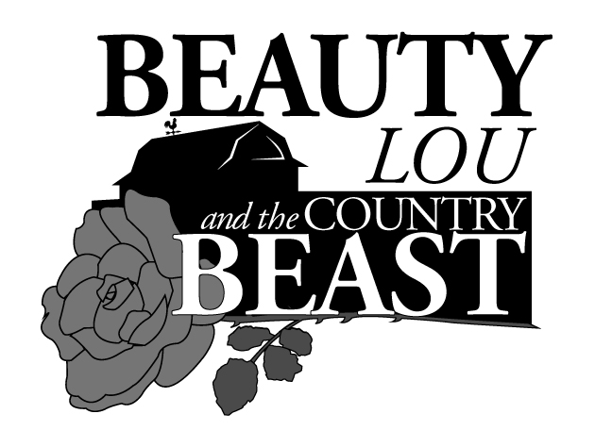  Conceived and Written by  JIM CARON  Music and Lyrics by  MICHAEL MCGILL and JIM CARON  Additional Music by  JON HART and MICHAEL SCHOONER  Copyright © 2011 MCT, Inc.  MISSOULA CHILDREN’S THEATRE (MCT, INC)  200 North Adams Missoula, Montana 59802-4718  Phone 406-728-1911 Fax 406-721-0637  MCTinc.org  All Rights Reserved  BEAUTY LOU AND THE COUNTRY BEAST SYNOPSIS  Missoula Children’s Theatre presents BEAUTY LOU AND THE COUNTRY BEAST, an original country western adaptation of the classic fairy tale BEAUTY AND THE BEAST. Beauty Lou is the oldest daughter of the bronc-bustin’ balladeer Buck. At the local county fair, young Beauty Lou is upset by the ungrateful behavior of a miner who has won the blue ribbon for his beautiful roses. She calls him a beast and wishes that he would look like one too. Years later, when in danger of losing the family farm, Buck meets the miner-turned-beast. Beauty Lou agrees to befriend the Beast to save her family. Beauty Lou and the Beast both learn to look beyond appearances and first impressions and to see the beauty that dwells inside. The story, set in the American West, also features Beauty Lou’s six sisters, her Imaginary Friend, her dog Fleabite Clyde, farmhands Slim and Dusty, the neighborly Country Folk and the Barnyard Critters.  TOUR SPONSORS  The Missoula Children’s Theatre domestic Tour is sponsored by Cosmic Crisp®, a new apple grown exclusively in Washington state. The Cosmic Crisp® motto, “Imagine the Possibilities™”, aligns with MCT’s work sparking children’s imaginations and creativity through theatre participation.  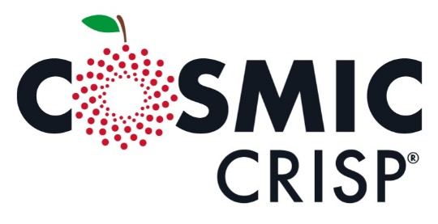  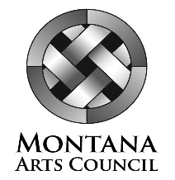  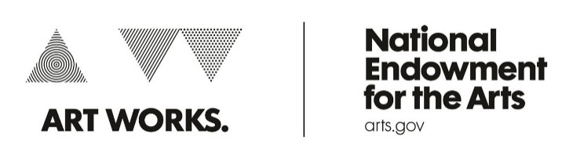  This project is partially supported by the National Endowment for the Arts. Supported in part by a grant from the Montana Arts Council, an Agency of the State Government, and the National Endowment for the Arts.

