About Program Notes

Programs for performances can disperse valuable and interesting information. They also make terrific souvenirs for the cast.

We require that you include the following:

- The Missoula Children’s Theatre authorship credits for key creative personnel and copyright information found on the next page.

We encourage you to include the following at your discretion, should room permit:

- The included show synopsis and MCT company overview.

- All foundation and/or arts organization graphics included.

- Any local sponsoring organization logo or information.

- Complete list of cast members, assistant directors, accompanist, lighting technician, school staff and anyone else who helped to make your week a success.

Along with the following statements:

- There should be no flash photography during the performance. There will be a time for photos immediately following the show.

- Please observe the following video courtesies: keep the aisles clear and stay in one place while recording.

- Please silence all cell phones.

  Celebrating our 50th year of touring, the Missoula Children’s Theatre International Tour has fostered developmental life skills in more than a million kids. Prior to Covid, we worked with 65,000 children in more than 1,100 communities in all 50 states and 17 countries each year. Our reach is increasing once again, but like all performing arts organizations, Covid-19 has had a devastating impact on our budget. One of the many ways the Missoula Children’s Theatre remains vibrant is through generous donors all over the world. If you would like to help support MCT, GIVE online by visiting MCTinc.org or via text by texting “MCTGive” to 44321.    “Guess what? I made it…I’m in the play!”  On stage or behind the scenes, your children are STARS! We invite you to honor that experience with a “star” in the MCT Galaxy, located in MCT headquarters in Missoula, MT! To see a sample of the MCT Galaxy and learn more about this exciting way to celebrate your star and support MCT, search “galaxy” in the search bar on our website. Stars are only $50 and can be customized with a name, the memory you wish to commemorate, date and location.    Missoula Children’s Theatre  200 N. Adams, Missoula, MT 59802-4718  MCTinc.org 406-728-1911 tour@MCTinc.org |  | 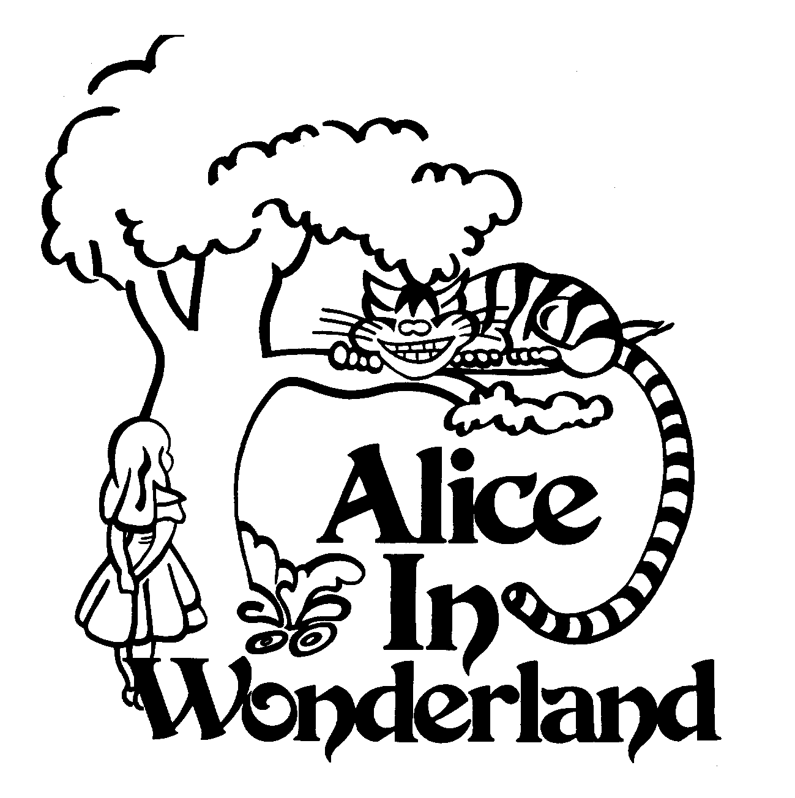  Based upon “Alice’s Adventures in Wonderland” and  “Through the Looking Glass” by Lewis Carroll  Music by  DAVID W. SIMMONS  Lyrics by  LEWIS CARROLL, WILLIAM SHAKESPEARE  and DAVID W. SIMMONS  Staging by  DON KUKLA  Copyright © 2011 MCT, Inc.  MISSOULA CHILDREN’S THEATRE (MCT, INC)  200 North Adams Missoula, Montana 59802-4718  Phone 406-728-1911 Fax 406-721-0637  MCTinc.org  All Rights Reserved
CAST OF CHARACTERS  Tall Alice  Middle Alice  Small Alice  Margaret  King of Hearts  Knave of Hearts  Queen of Hearts  Ace of Hearts  Gryphon  Mock Turtle  March Hare  Mad Hatter  Dormouse  Duchess  Cook  Fish  Frog  Humpty Dumpty  Cheshire Cat 1  Cheshire Cat 2  Cheshire Cat 3  Tweedle Dee  Tweedle Dum  Caterpillar Head  Caterpillar Body  Flowers  Cards  Lobsters  Assistant Directors  Accompanist  White Rabbit–Tour Actor/Director  Director–Tour Actor/Director |  | ALICE IN WONDERLAND SYNOPSIS  The Missoula Children’s Theatre presents ALICE IN WONDERLAND, an original adaptation based on Lewis Carroll’s Alice’s Adventures in Wonderland and Through the Looking Glass. The story begins with Alice and her older sister Margaret reading together. Margaret becomes frustrated, as Alice is curious about absolutely everything. Suddenly, a White Rabbit appears from nowhere. After a quick and nonsensical conversation, Alice follows the rabbit to a strange and wonderful place. In the course of her adventures, Alice meets a band of Flowers, the King and Queen of Hearts, the Knave and the rest of the suit of Cards, a giant Caterpillar, a Fish, a Frog, the Duchess, the Cook, the Cheshire Cat, the Gryphon, the Mock Turtle, a group of singing Lobsters, Tweedle Dee and Tweedle Dum, the March Hare, the Mad Hatter, the Dormouse and Humpty Dumpty. Through it all, Alice grows “curiouser and curiouser” as to where she is and even who she is. In the end, the answers she seeks are unimportant. Wonderland is all nonsense, anyway. As the White Rabbit explains, “Nonsense is fun!”  TOUR SPONSORS  The Missoula Children’s Theatre domestic Tour is sponsored by Cosmic Crisp®, a new apple grown exclusively in Washington state. The Cosmic Crisp® motto, “Imagine the Possibilities™”, aligns with MCT’s work sparking children’s imaginations and creativity through theatre participation.    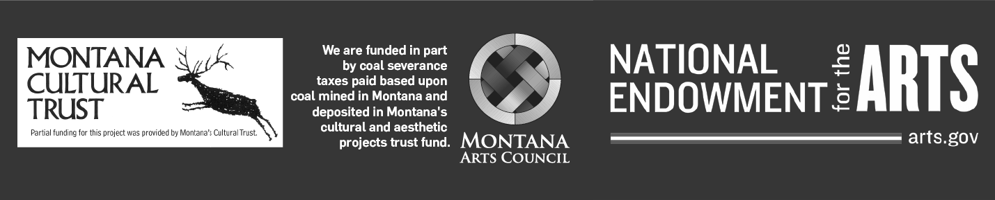  This project is partially supported by the National Endowment for the Arts. Supported in part by a grant from the Montana Arts Council, an agency of the State Government, and the National Endowment for the Arts.

