About Program Notes

Programs for performances can disperse valuable and interesting information. They also make terrific souvenirs for the cast.

We require that you include the following:

- The Missoula Children’s Theatre authorship credits for key creative personnel and copyright information found on the next page.

We encourage you to include the following at your discretion, should room permit:

- The included show synopsis and MCT company overview on back page.

- All foundation and/or arts organization graphics included.

- Any local sponsoring organization logo or information.

- Complete list of cast members, assistant directors, accompanist, lighting technician, school staff and anyone else who helped to make your week a success.

Along with the following statements:

- There should be no flash photography during the performance. There will be a time for photos immediately following the show.

- Please observe the following video courtesies: keep the aisles clear and stay in one place while recording.

- Please silence all cell phones.

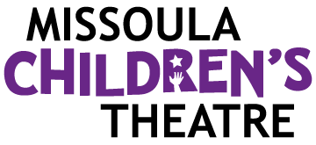  Celebrating over 50 years of touring, the Missoula Children’s Theatre International Tour has fostered developmental life skills in more than a million kids. Our tour reaches 65,000 children in more than 1,000 communities in all 50 states and 15+ countries each year. One of the many ways the Missoula Children’s Theatre remains vibrant is through generous donors all over the world. If you would like to support MCT, visit MCTinc.org/give or text “MCTGive” to 44321.    “Guess what? I made it…I’m in the play!”  On stage or behind the scenes, your child is a STAR! We invite you to honor their experience with a “star” in the MCT Galaxy, located in MCT headquarters in Missoula, MT! To see a sample of a star and learn more about this unique way to celebrate your child and support MCT, visit MCTinc.org/get-involved/mct-galaxy-wall. Stars are only $50 and can be customized with a name, the memory you wish to commemorate, date and location.    Missoula Children’s Theatre  200 N. Adams, Missoula, MT 59802-4718  MCTinc.org 406-728-1911 tour@MCTinc.org |  |  |  | 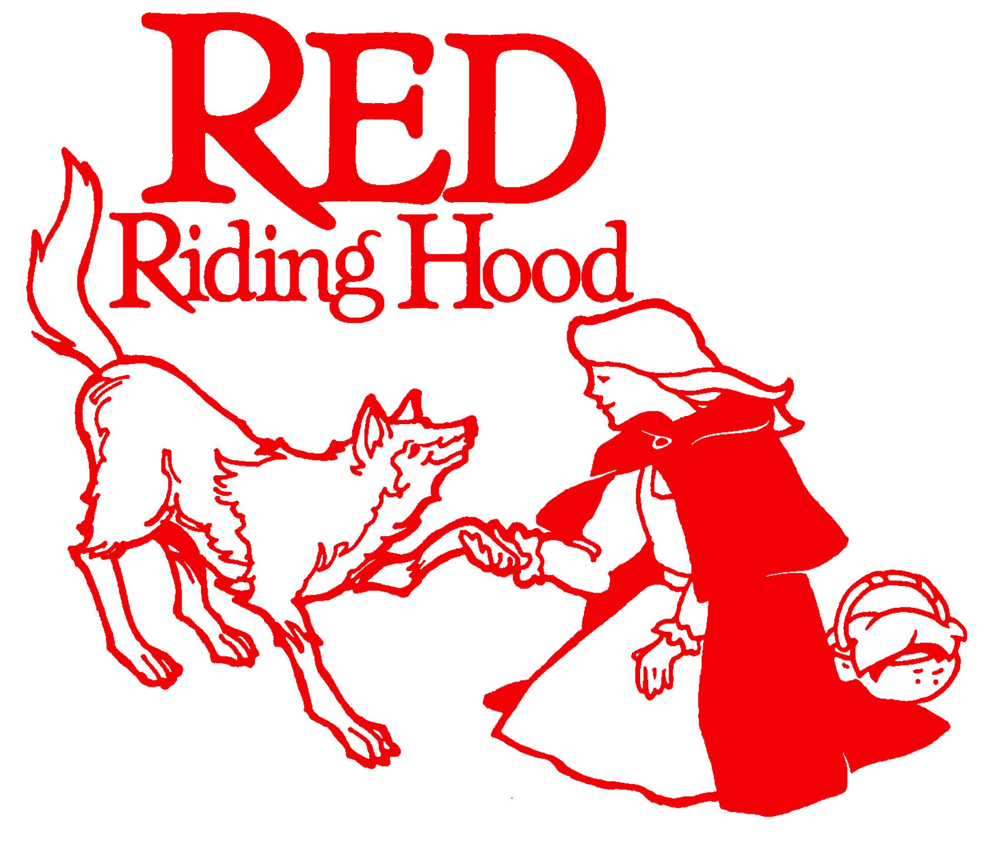  Adapted by  MICHAEL MCGILL  Music by  MICHAEL MCGILL  Copyright © 2011 MCT, Inc.  MISSOULA CHILDREN’S THEATRE (MCT, INC)  200 North Adams Missoula, Montana 59802-4718  Phone 406-728-1911 Fax 406-721-0637  MCTinc.org  All Rights Reserved
Cast of Characters:  Red Riding Hood  Mother Hood/Grandma  Ranger Rooney  Sister Hood  Brother Hood  Baby Hood  Robin Hood  The Locksmith  The Woodsman  The Boy Who Cries Wolf  Little Loveable Wolf  Girl Friends  Three Little Pigs  The Wolfgang  Forest Shadows  Raccoons  Assistant Directors  Accompanist  Big Bad Wolf–Tour Actor/Director  Director–Tour Actor/Director |  |  |  | RED RIDING HOOD SYNOPSIS  Over the river and through the woods to Grandmother’s house she goes. Red Riding Hood, not so little anymore, and her pre-teen pals try to stay on the straight and narrow in the latest adventure from the Missoula Children's Theatre, RED RIDING HOOD. The Big Bad Wolf, who is not so bad after all, and a friendly neighborhood Forest Ranger urge our heroes to stay true to the path, for in the Shadows lurk diversions and a sinister surprise or two. A pack of woefully nasty young wolves and a handsome Woodsman, too good to be true, are a must for our story. And we can’t have a wolf tale without Three Little Pigs and even a Boy Who Cries…you guessed it. With help from her family and a loyal young Locksmith (he carries the key), Red finds her Grandma and a whole lot more. Now if only she could retrieve her picnic basket from those rascally Raccoons. Life is no picnic when you stray from the trail!  TOUR SPONSORS  

