About Program Notes

Programs for performances can disperse valuable and interesting information. They also make terrific souvenirs for the cast.

We require that you include the following:

- The Missoula Children’s Theatre authorship credits for key creative personnel and copyright information found on the next page.

We encourage you to include the following at your discretion, should room permit:

- The included show synopsis and MCT company overview.

- All foundation and/or arts organization graphics included.

- Any local sponsoring organization logo or information.

- Complete list of cast members, assistant directors, accompanist, lighting technician, school staff and anyone else who helped to make your week a success.

Along with the following statements:

- There should be no flash photography during the performance. There will be a time for photos immediately following the show.

- Please observe the following video courtesies: keep the aisles clear and stay in one place while recording.

- Please silence all cell phones.

  Celebrating over 50 years of touring, the Missoula Children’s Theatre International Tour has fostered developmental life skills in more than a million kids. Our tour reaches 65,000 children in more than 1,000 communities in all 50 states and 15+ countries each year. One of the many ways the Missoula Children’s Theatre remains vibrant is through generous donors all over the world. If you would like to support MCT, visit MCTinc.org/give or text “MCTGive” to 44321.    “Guess what? I made it…I’m in the play!”  On stage or behind the scenes, your child is a STAR! We invite you to honor their experience with a “star” in the MCT Galaxy, located in MCT headquarters in Missoula, MT! To see a sample of a star and learn more about this unique way to celebrate your child and support MCT, visit MCTinc.org/get-involved/mct-galaxy-wall. Stars are only $50 and can be customized with a name, the memory you wish to commemorate, date and location.    Missoula Children’s Theatre  200 N. Adams, Missoula, MT 59802-4718  MCTinc.org 406-728-1911 tour@MCTinc.org |  |  |  | 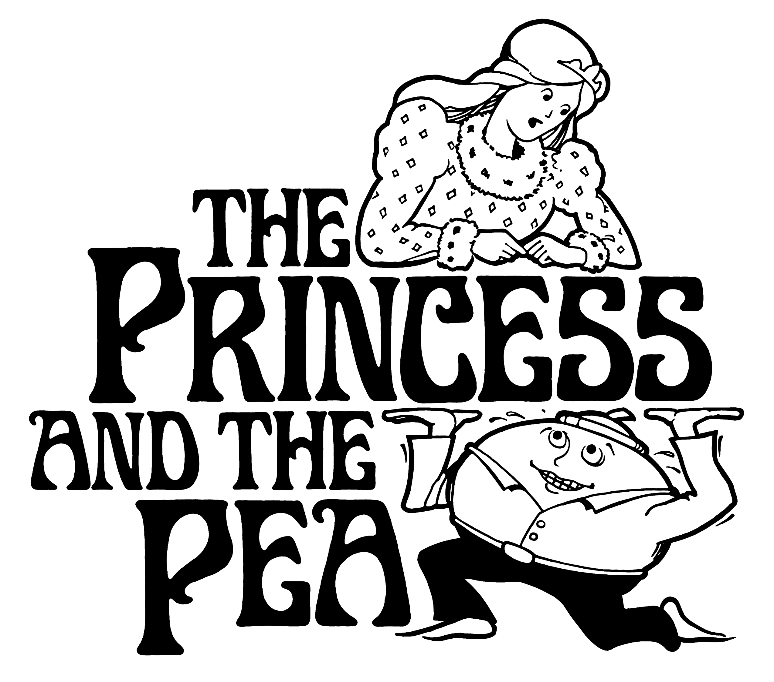  Adapted by  MICHAEL MCGILL  Music and Lyrics by  Michael McGill  Copyright © 2006 Michael McGill & MCT, Inc.  MISSOULA CHILDREN’S THEATRE (MCT, INC)  200 North Adams Missoula, Montana 59802-4718  Phone 406-728-1911 Fax 406-721-0637  MCTinc.org  All Rights Reserved
Cast of Characters:  Glacierdom  Storm King  Snow Queen  Prince Ice Man  Jack Frost  Phony Princesses  Gale  Winter Wind Workers  Bitter  Blizzard Bringers  Grinder  Icicle Sharpeners  Powder  Snow Smoothers  Riverdom  King Size  Queen Size  Princess  Pea  Phony Princesses  Fuschia  Flower Gardeners  Splash  River Runners  Bud  Green Shoot Growers  Pug  Tree Barkers  Tree Biter  Leprechaun Clan  Dust Bunnies  Assistant Directors  Accompanist  Chief (Head of the Leprechauns)–Tour Actor/Director  Director–TourActor/Director |  |  |  | THE PRINCESS AND THE PEA SYNOPSIS  Envision a kingdom of snow where the residents are Winter Wind Workers, Blizzard Bringers, Icicle Sharpeners and Snow Smoothers, ruled by the Storm King and the Snow Queen. Add to that a Prince looking for a proper Princess to share the throne. Now imagine the Princess and her friend the Pea living in a kingdom of green rolling hills and running rivers with her subjects, The Flower Gardeners, River Runners, Green Shoot Growers and Tree Barkers. Her parents, King Size and Queen Size, do all they can to keep things running smoothly. Who knows, maybe the dancing Dust Bunnies can help? Although the two kingdoms think they have nothing in common (except maybe a pesky Jack Frost that freezes anything and everything), the peace-loving Leprechauns prove otherwise. Throw in some Phony Princesses and you have a real fiasco! This ain’t your grandma’s PRINCESS AND THE PEA. We think you will enjoy its twists and turns.  TOUR SPONSORS  

