ABOUT PROGRAM NOTES

Programs for performances can disperse valuable and interesting information. They also make terrific souvenirs for the cast.

We require that you include the following:

- The Missoula Children’s Theatre authorship credits for key creative personnel and copyright information found on the next page.

We encourage you to include the following at your discretion, should room permit:

- The included show synopsis and MCT company overview on back page.

- All foundation and/or arts organization graphics included.

- Any local sponsoring organization logo or information.

- Complete list of cast members, assistant directors, accompanist, lighting technician, school staff and anyone else who helped to make your week a success.

Along with the following statements:

- There should be no flash photography during the performance. There will be a time for photos immediately following the show.

- Please observe the following video courtesies: keep the aisles clear and stay in one place while recording.

- Please silence all cell phones.

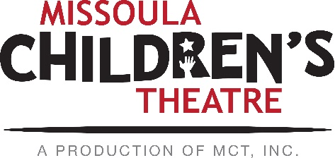  Celebrating over 50 years of touring, the Missoula Children’s Theatre International Tour has fostered developmental life skills in more than a million kids. Our tour reaches 65,000 children in more than 1,000 communities in all 50 states and 15+ countries each year. One of the many ways the Missoula Children’s Theatre remains vibrant is through generous donors all over the world. If you would like to support MCT, visit MCTinc.org/give or text “MCTGive” to 44321.  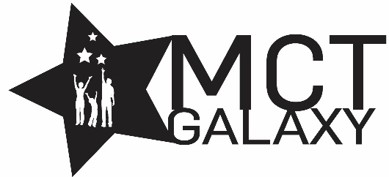  “Guess what? I made it…I’m in the play!”  On stage or behind the scenes, your child is a STAR! We invite you to honor their experience with a “star” in the MCT Galaxy, located in MCT headquarters in Missoula, MT! To see a sample of a star and learn more about this unique way to celebrate your child and support MCT, visit MCTinc.org/get-involved/mct-galaxy-wall. Stars are only $50 and can be customized with a name, the memory you wish to commemorate, date and location.    Missoula Children’s Theatre  200 N. Adams, Missoula, MT 59802-4718  MCTinc.org 406-728-1911 tour@MCTinc.org |  |  |  | 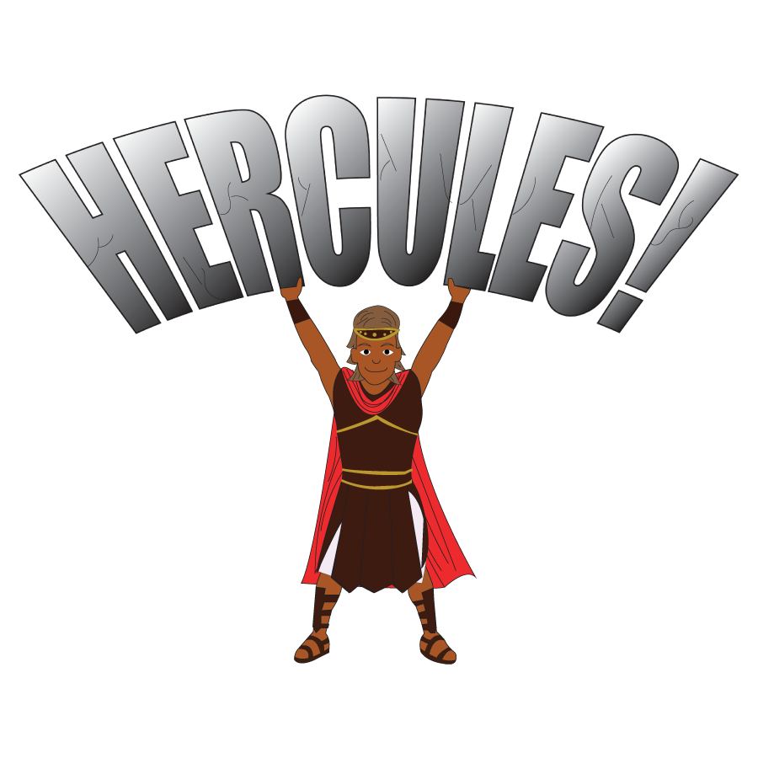  Adapted by  MICHAEL MCGILL AND JOSEPH MARTINEZ  Music and Lyrics by  Michael McGill  Copyright © 2018, 2022 Michael McGill, Joseph Martinez & MCT, Inc.  MISSOULA CHILDREN’S THEATRE (MCT, INC)  200 North Adams Missoula, Montana 59802-4718  Phone 406-728-1911 Fax 406-721-0637  www.MCTinc.org  All Rights Reserved
Cast of Characters:  Hercules  Androcles  Socrates  Aristotle  Zeus  Hera  Helen of Troy  Pegasus  Archimedes  Homer  Lion  Cyclops  Influencers  Olympians  Titans  Assistant Directors  Accompanist  Plato-Tour Actor/Director  Director-Tour Actor/Director |  |  |  | HERCULES SYNOPSIS  Welcome to Ancient Greece, where the focus is on the big tournament! The Olympic Games are starting soon, and the Cyclops and Titans are both expecting to win big in the Games. But the tournament can’t start without Hercules. Will the legendary strongman of the ancient World spark the flame and start the festivities on time, or will his legendary tardiness get in the way of the Games? Join us for a tale the scholars will talk about for ages as mythical creatures and Olympians alike share in a friendly competition. Along the way we may just learn that true strength lies not in our muscles but in our character.  TOUR SPONSORS  The Missoula Children’s Theatre domestic Tour is sponsored by Cosmic Crisp®, an apple grown exclusively in Washington state. The Cosmic Crisp® motto, “Imagine the Possibilities™”, aligns with MCT’s commitment to sparking children’s creativity and imagination through theatre participation.  