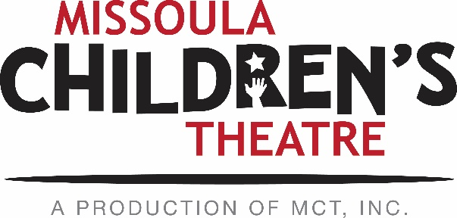

March 8, 2019
Dear Performing Arts Camp Applicants,

The time has come for Performing Arts Camp Applications! We are so excited that you are interested in participating in Missoula Children’s Theatre’s 2019 Performing Arts Camps! Specifics regarding camp dates, locations, application requirements, and fees can be found below. The camp application is an online form – no need to print and submit this year! Applications for all are due to MCT April 12, 2019 by 5:00 PM MST.
EAST SHORE CAMP: Current grades 5, 6, 7: Jul. 28 – Aug. 3
East Shore Camp is a week-long, skill-building theatre camp for students currently in grades 5-7. Located on the shores of Seeley Lake at Camp Paxson, the campers’ last event is singing and dancing in a small showcase. Tuition for East Shore Camp is $525.
NORTH SHORE CAMP: Current grades 8, 9, 10: Jul. 28 – Aug. 11
SOUTH SHORE CAMP: Current grades 11, 12: Jul. 27 – Aug. 11
Applicants currently in grades 8-10 are eligible for our North Shore Camp. Current Juniors and Seniors are eligible to apply for South Shore Camp. Both camps take place concurrently at separate campgrounds on Flathead Lake. Campers spend much of their day in rehearsals and classes preparing for 6 sold-out performances in Missoula at the MCT Center for the Performing Arts August 8th-10th. Students can elect to partake in voice, acting or dance lessons for an additional cost of $20/lesson. Tuition for North & South Shore is $1,000.
Due to the success and growth of our program, which is great, we need to make changes in the age ranges of our camp locations. East Shore will now be for those students currently in 5th, 6th and 7th grades, North Shore will be for those students currently in 8th, 9th and 10th grades, and South Shore will be for those students currently in 11th and 12th grades. We appreciate your understanding as our programming is growing and changing!

NORTH SHORE CAMP is returning to our old stomping grounds! We’re very pleased to be heading back to Flathead Lake United Methodist Campground! You can visit their website here for more information on this fantastic facility!

As a returning camper, you can lock in a lower rate by paying in full by April 26, 2019 at 5:00 PM MST. Paid-in-full early bird rates are $500 for East Shore and $975 for North and South Shore. After submitting your application, please give me a couple days to process your application into our payment system before calling to make a payment. **If you plan to apply for an MCT scholarship, please do not pay in full before receiving your scholarship decision. Scholarships will be announced by April 24, 2019**
Returning campers DO NOT need to re-audition for acceptance. Current 8th graders who attended East Shore in 2018 DO NOT need to audition this year to move up. Please remember this letter serves as an invitation to our program, with future invitations contingent upon your behavior while at camp. If we do not receive your application by the April 12th deadline, we cannot guarantee you a spot at camp. We ask you to strongly consider the commitment you are undertaking in requesting to return to our program.
You can find all this information and more in the online 2019 PAC Applicant Hub here! I will be in the office part-time throughout paperwork/prep time - please refer to this website for important dates, documents and the online application.
Please feel free to contact me via email if you have any questions. I look forward to hearing from you soon!

