FOR IMMEDIATE RELEASE –
THE MISSOULA COMMUNITY THEATRE 2019-20 SEASON

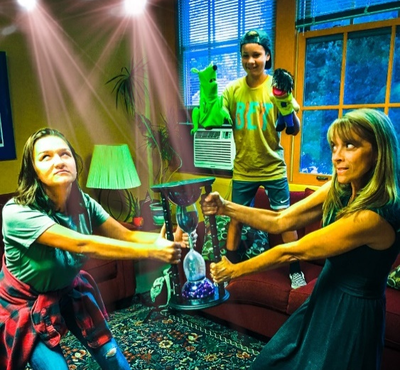

Daughter Ellie (Caydance Wilson, left) and her mom Katherine (Darci Monsos)
experience a magical hourglass moment that leads to a very Freaky Friday,
while brother Fletcher (Sawyer Partain) looks on.

Missoula, MT— The Missoula Community Theatre (MCT) proudly presents the new musical, Freaky Friday, Oct. 24-Nov. 3 at the MCT Center for the Performing Arts. When a story is genuinely compelling, it contains the power to be retold in many different ways, and to speak across generations. Such is the case with Freaky Friday, which has entertained families since the original 1972 Mary Rodgers book was released and subsequently produced into two successful movies.

Director Joseph Martinez says most people are probably familiar with the story: a frazzled mom and angsty daughter magically switch bodies and lives for one day, which creates frustration for them and comedy for the audience. But Martinez says the musical successfully reaches further. “This script surprised me that it is much deeper…the story focuses on issues children and parents are going through and are afraid to tell anyone. It’s a beautifully written script.” Mom and daughter unexpectedly find compassion and respect for the other’s journey, and newer, more tender definitions of family are allowed to grow and blossom.

Martinez has found working with the Freaky Friday cast absolutely delightful. “The energy is amazing. They love what they are doing. The cast has really taken on the responsibility of telling this story.” The enthusiasm the teen cast members infuse into the show has been exhilarating, he notes. “It’s fun when you can have a cast of teenagers playing teenagers.” He says it’s been an exciting, gratifying experience to see the “kids that have grown up learning in our children’s programs and then performing in the ensembles of our community theatre take on leads and carry a show. Seeing that growth is always invigorating.”

Martinez is confident that audiences will not only enjoy the story and musical score of Freaky Friday, but that it will strike chords with people on a heart level. Tickets for Disney’s Freaky Friday are available at MCTinc.org.

*Freaky Friday will take place at the MCT Center for the Performing Arts Oct. 24-Nov. 3, 2019. Tickets are available at MCTinc.org; by calling 406-728-PLAY(7529); or at the MCT Box Office, which is open Mon.-Fri. between 9AM and 5PM. The production is sponsored by TrailWest Bank, Madison Creek Furnishings, and Equity Management Inc. Freaky Friday is presented through special arrangement with Music Theatre International (MTI). All authorized performance materials are also supplied by MTI. www.MTIShows.com
MCT, Inc. | 200 North Adams St., Missoula, MT 59802 | 406-728-7529 | mct@MCTinc.org | www.MCTinc.org

