FOR IMMEDIATE RELEASE –
THE MISSOULA COMMUNITY THEATRE 2019-20 SEASON

AUDITION for
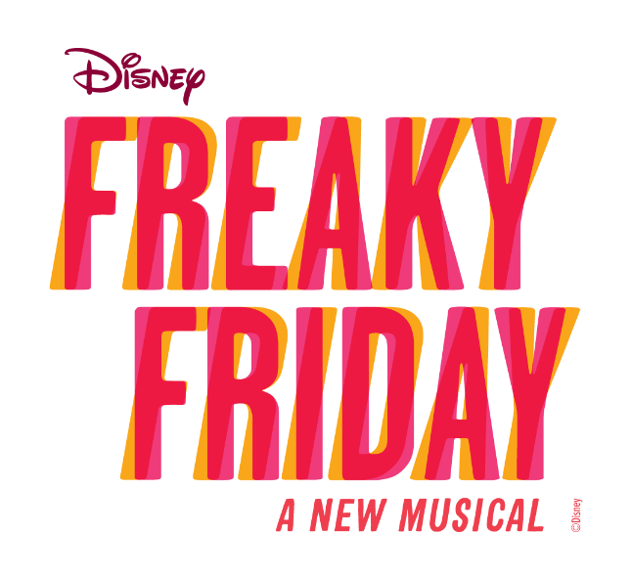
Missoula, MT— The Missoula Community Theatre will hold an open audition for Disney’s Freaky Friday on Sunday, August 25 from 12:30-4:00 PM. Please use the Main Street entrance and go to the third floor.
In this lively new musical based on the popular novel and Disney movies, mom and daughter, Katherine and Ellie, both have strong opinions on how the other should live her life. In one magical moment, the frazzled single mom and her rebellious teenage daughter switch bodies, and a chaotic comedy of errors ensues! In addition to the delightfully heartwarming story, Freaky Friday contains a score/lyrics composed by the Tony and Pulitzer Prize winning team of Tom Kitt and Brian Yorkey (Next to Normal).
The audition is open to women, men, and children ages 12 and up. Director Joseph Martinez will audition adults (age 17 and up) from 12:30-2:00 PM. Children/teens (ages 12-16) will audition from 2:00-4:00 PM. Martinez is expecting to cast approximately 14 females and 14 males. Other than Katherine and Ellie, some of the roles to be cast are Katherine’s eccentric young son, Fletcher, and easy-going fiancé, Mike, as well as Ellie’s teen love interest, Adam. Martinez says there are “lots of fun roles for adults and teenagers.”
No advance preparation is required to audition. Call-backs will take place the same evening. Martinez expects that rehearsals will be weeknights from 7-10:30 PM. Those auditioning should note that Disney’s Freaky Friday performances are October 24-November 3.
**For questions regarding auditions, or to inquire about a perusal script, please call MCT at 728-PLAY(7529) Monday-Friday between 9AM and 5PM.
200 North Adams St., Missoula, MT 59802 | 406-728-7529 | mct@MCTinc.org | www.MCTinc.org

