Adapted by

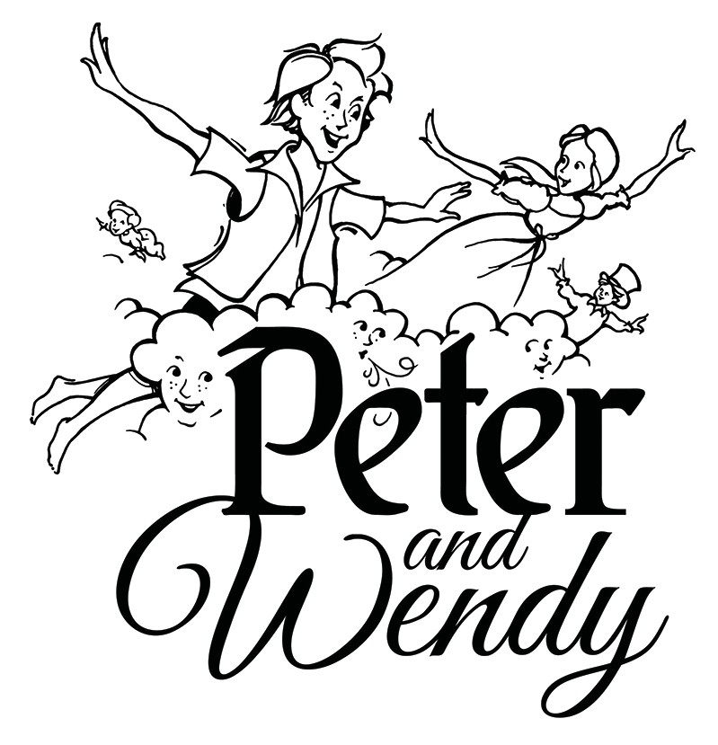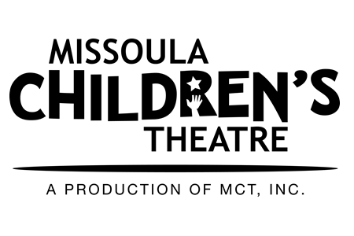

**Michael McGill**

Music and Lyrics by

**Michael McGill**