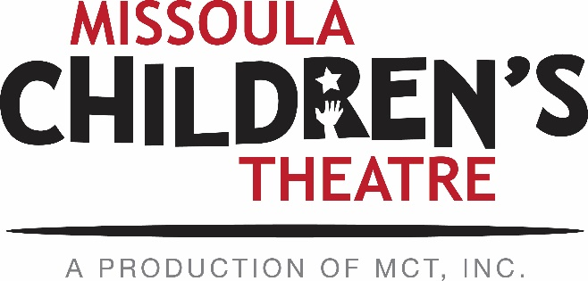

PERFORMING ARTS CAMP AUDITION INFORMATION
All applications and audition materials due by April 14, 2017.

Applicants within 100 miles of Missoula:
These applicants may attend an audition session Saturday, April 15, at 10 A.M. at MCT’s facility, 200 N. Adams in Missoula. The completed online application, two letters of recommendation, and your intention to audition in Missoula must arrive at MCT by April 1. On the day of the auditions, applicants will be asked to present a 1-2 minute prepared song and a 1-2 minute memorized monologue. Please bring along sheet music, as an accompanist will be provided. If April 15 is a conflicting date for you, please prepare a recorded audition (see details below).

Applicants living more than 100 miles from Missoula:
Applicants must submit the following materials:
- Online 2017 PAC Application Form
- 2 Letters of recommendation (from non-family members)
- Video audition, including
  - Introduction
  - 1-2 minute accompanied song
  - 1-2 minute memorized monologue

Your online application and audition materials can be submitted electronically by email, or mailed to the address listed below. You can upload your audition to Youtube or Vimeo (be sure the video is NOT set to “private”), and send us the link before the April 14th deadline. If you would prefer to mail in a DVD of your audition, you may do so at the address found below. The audition selections should strongly display the vocal and acting ability of the applicant. Please DO NOT send an excerpt of a recent local production or an MCT show; viewing an accompanied song and a monologue that have been prepared especially for this audition is preferred. If you are using a phone to record your audition – please be sure to hold the phone horizontally so that the video is not flipped. All DVDs should be clearly labeled with the applicant’s first and last name as well as their mailing address. Please send all materials together, and not separately. Those wishing their DVDs returned should include an appropriate self-addressed, stamped envelope. DVDs without return postage become the property of MCT, Inc.

SUBMIT MATERIALS TO:
MCT Center for the Performing Arts/PAC
ATTN: Kirsten Paisley
200 N. Adams
Missoula, MT 59802

(406) 728-1911
E-mail: KPAISLEY@MCTINC.ORG
MCT Website: www.MCTinc.org

