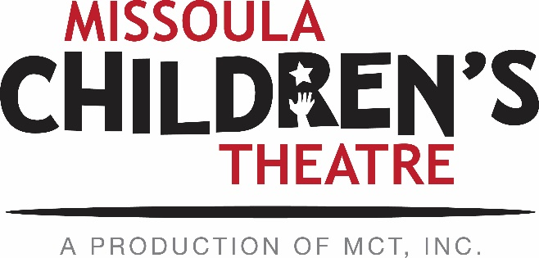

PERFORMING ARTS CAMP AUDITION INFORMATION
All applications and audition materials due by April 12, 2019.

All new PAC applicants must submit the following materials:
- 2019 PAC Application (online form)
- New PAC applicant Essay – Why are the Performing Arts important to you? (online form)
- Audition (either live at MCT or recorded)
  - Introduction of yourself and your audition pieces
  - 1-minute accompanied song
  - 1-minute memorized monologue

Applicants within 100 miles of Missoula:
Local applicants may attend a live audition session Saturday, April 13, at 10 A.M. at MCT’s facility, 200 N. Adams in Missoula. The completed online application (stating your intention to audition live in Missoula) and essay must be received by MCT by 5 PM MST on April 12. On the day of the auditions, applicants will be asked to present a 1-minute prepared song and a 1-minute memorized monologue. Please bring along sheet music, as an accompanist will be provided. If April 13 is a conflicting date for you, please prepare a recorded audition (see details below).

Applicants living more than 100 miles from Missoula:
- Video auditions must include the following:
  - Introduction of yourself and your audition pieces
  - 1-minute accompanied song
  - 1-minute memorized monologue

After submitting the 2019 PAC application and essay, your video audition materials can be submitted electronically by email, or mailed to the address listed below. You can upload your audition to Youtube or Vimeo (be sure the video is NOT set to “private”) and send us the link before the April 12th deadline. You can also share the video via google drive with PACauditions@gmail.com. If you would prefer to mail in a DVD of your audition, you may do so at the address found below. The audition selections should strongly display the vocal and acting ability of the applicant. Please DO NOT send an excerpt of a recent local production or an MCT show; viewing an accompanied song and a monologue that have been prepared especially for this audition is preferred. If you are using a phone to record your audition – please be sure to hold the phone horizontally so that the video is not flipped.

SUBMIT MATERIALS TO:
MCT Center for the Performing Arts/PAC
ATTN: Kirsten Paisley
200 N. Adams
Missoula, MT 59802

