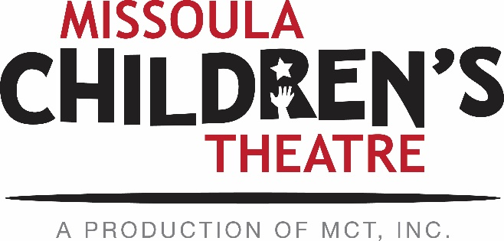

PERFORMING ARTS CAMP 2017 INFORMATION

DATES: East Shore Camp: July 30 – August 5, 2017
North Shore Camp: July 30 – August 13, 2017
South Shore Camp: July 29 – August 13, 2017

ELIGIBILITY:
All students entering grades 6 - 7 in the fall of 2017 are eligible for East Shore.
All students entering grades 8 -10 in the fall of 2017 are eligible for North Shore.
All students entering grades 11-13 in the fall of 2017 are eligible for South Shore.

FEE: The tuition for East Shore is $475 per camper. North and South Shore tuition is $925 per camper. Fee includes room, board, and a commemorative T-shirt. Upon acceptance to the East Shore camp, a deposit in the amount of $250 must be remitted to MCT, Inc. Applicants accepted to either the North or South Shore camps will send a deposit of $400. The deposit is non-refundable and is due June 2, 2017. The remaining tuition amount, minus the deposit, is due July 1, 2017. Payments can be made by mailing a check to MCT c/o Kirsten Paisley, 200 N Adams St, Missoula, MT 59802, or by calling 406-728-1911 to make a CC payment over the phone with Kirsten or Anna.

SCHOLARSHIPS: A limited number of partial tuition assistance scholarships are available. These scholarships are awarded via a written application and are based upon financial need and distance from camp. Individuals wishing to apply must request a scholarship form from MCT prior to April 1, 2017. A scholarship request does not influence consideration for acceptance. Scholarships will be awarded after camper positions are filled. The deadline for scholarship applications is May 12, 2017, and scholarship money will be awarded shortly after.

TRANSPORTATION: Transportation to and from Missoula is the responsibility of each camper. MCT will transport North and South Shore campers from the campground on Flathead Lake to Missoula for the production weekend. For those traveling to camp from out of state, we do have bussing available from the Missoula Airport to camp for a small transportation fee of $10.

NORTH AND SOUTH ONLY: Performances: August 10-12 in Missoula. Campers stay with either their parents or host families while in Missoula August 9-13.

APPLICATIONS: You can fill out the online application here! No need to print and fill it out this year! The link can also be found at the bottom of the 2017 PAC Applicant Information Hub. The deadline for application/recorded audition consideration is Friday, April 14, 2017.

