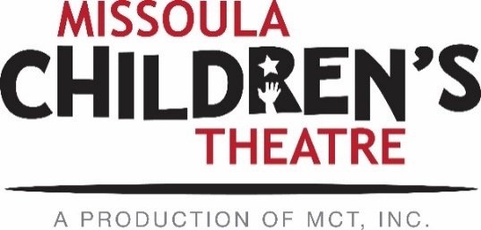

March 8, 2019
Dear Performing Arts Camp Applicants,

The time has come for Performing Arts Camp Applications! We are so excited that you are interested in participating in Missoula Children’s Theatre’s 2019 Performing Arts Camps! MCT offers 3 camps for which students currently in grades 5-12 are eligible to attend. Specifics regarding camp dates, application/audition requirements, and fees can be found below. The camp application is an online form – no need to print and submit this year! All applications and audition materials are due to MCT April 12, 2019.
EAST SHORE CAMP: Current grades 5, 6, 7: Jul. 28 – Aug. 3
East Shore Camp is a week-long, skill-building theatre camp for students currently in grades 5-7. Located on the shores of Seeley Lake at Camp Paxson, the campers’ last event is singing and dancing in a small showcase. Tuition for East Shore Camp is $525.
NORTH SHORE CAMP: Current grades 8, 9, 10: Jul. 28 – Aug. 11
SOUTH SHORE CAMP: Current grades 11, 12: Jul. 27 – Aug. 11
Applicants currently in grades 8-10 are eligible for our North Shore Camp. Current Juniors and Seniors are eligible to apply for South Shore Camp. Both camps take place concurrently at separate campgrounds on Flathead Lake. Campers spend much of their day in rehearsals and classes preparing for 6 sold-out performances in Missoula at the MCT Center for the Performing Arts August 8th-10th. Students can elect to partake in voice, acting or dance lessons for an additional cost of $20/lesson. Tuition for North & South Shore is $1,000.
For NEW CAMP APPLICANTS, information on auditioning is included. Applications and auditions are due by April 12, 2019. Applicants within a close radius to Missoula will have the opportunity to audition at the MCT Center for the Performing Arts on Saturday, April 13 at 10 A.M. Applicants outside the Missoula area will need to submit their recorded materials by April 12. Please see the audition information document for more info!
You can find all this information, the link to the online application, and more in the online 2019 PAC Applicant Hub here! I will be in the office part-time throughout paperwork/prep time. The best way to contact me with questions is via email. Please refer to the PAC HUB for important dates, documents and the online application.

Please feel free to reach out if you have any questions. I look forward to hearing from you soon!

